R Programs with Output Screenshots (Scenarios 1-10)

Scenario 1 – Student Academic Performance
R Program:
library(ggplot2)
student <- data.frame(
Attendance=c(75,80,85,90,95),
Marks=c(60,68,75,85,95),
Department=c("CSE","AI","IT","ECE","CSE")
)
ggplot(student,aes(x=Attendance,y=Marks,color=Department))+
geom_point(size=4)+
labs(title="Student Academic Performance",
x="Attendance (%)",y="Internal Marks")

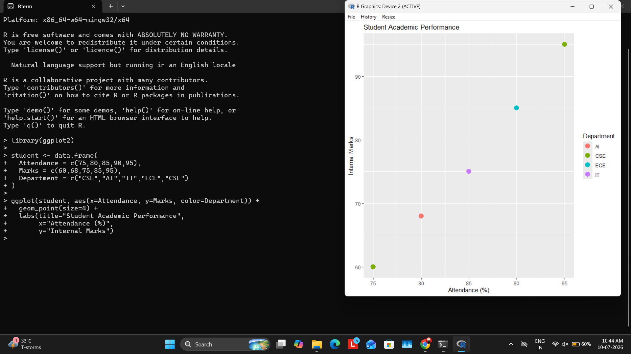

Scenario 2 – Electric Vehicle Market Analysis
R Program:
library(ggplot2)
ev <- data.frame(
Battery=c(30,40,50,60,70),
Price=c(8,10,12,15,18),
Range=c(250,300,350,420,500),
Manufacturer=c("Tata","MG","Hyundai","Mahindra","BYD")
)
ggplot(ev,aes(Battery,Price,size=Range,color=Manufacturer))+
geom_point(alpha=0.8)+
labs(title="EV Market Analysis",
x="Battery Capacity (kWh)",y="Price")

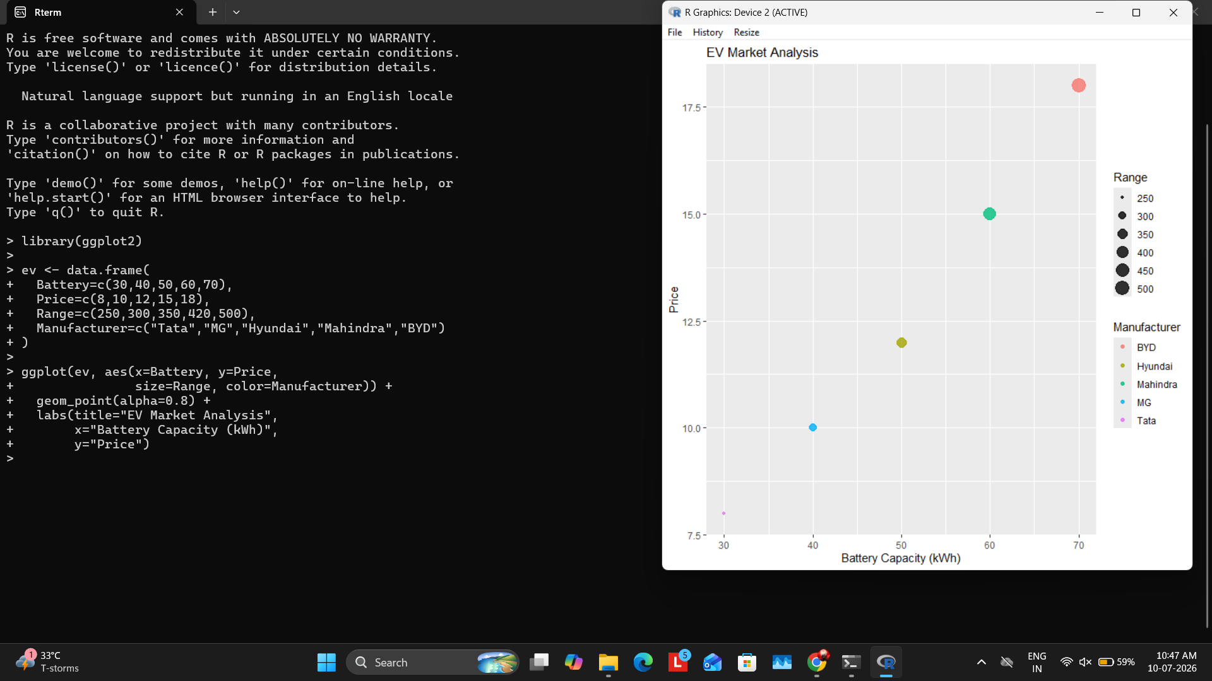

Scenario 3 – Hospital Patient Admission Analysis
R Program:
library(ggplot2)
hospital <- data.frame(
Department=c("Cardiology","ENT","Orthopedics","Neurology"),
Patients=c(120,80,100,60),
Cost=c(5000,2500,4000,7000)
)
ggplot(hospital,aes(Department,Patients,fill=Department))+
geom_bar(stat="identity")+
geom_text(aes(label=Cost),vjust=-0.5)+
labs(title="Hospital Patient Admission Analysis")
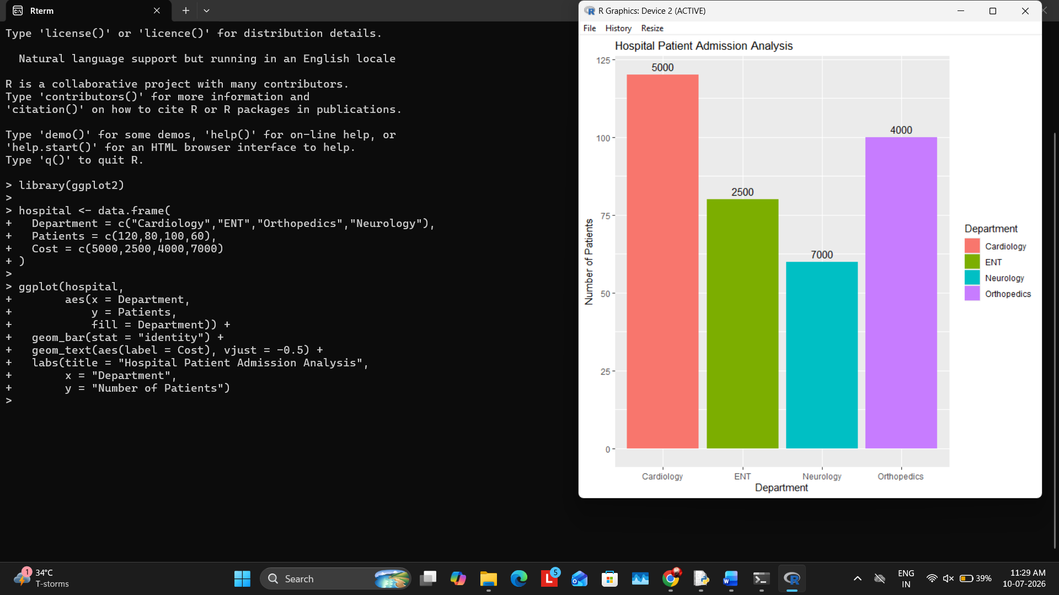

Scenario 4 – Weather Monitoring System
R Program:
library(ggplot2)
weather <- data.frame(
Date=rep(1:5,3),
Temp=c(30,31,32,31,30,28,29,30,31,32,26,27,28,29,30),
City=rep(c("Chennai","Delhi","Mumbai"),each=5)
)
ggplot(weather,aes(Date,Temp,color=City,linetype=City))+
geom_line(linewidth=1)

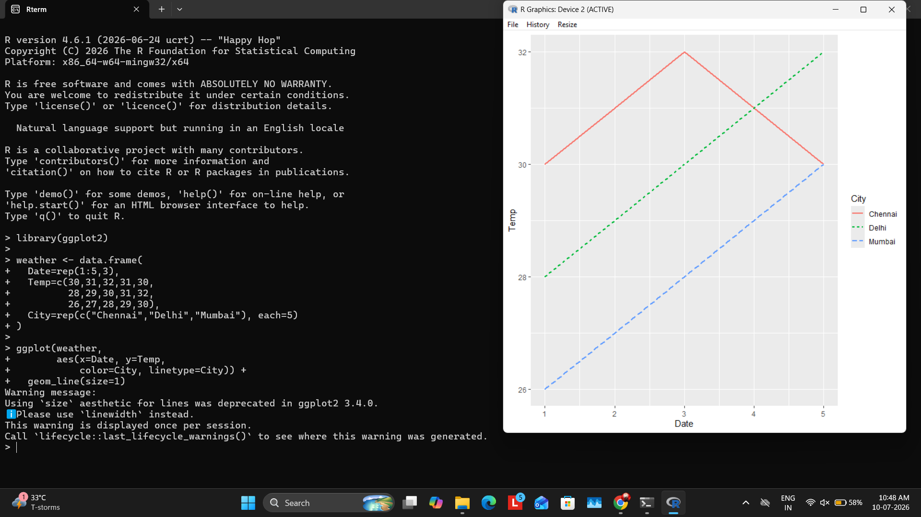

Scenario 5 – Supermarket Sales Analysis
R Program:
library(ggplot2)
sales <- data.frame(
Category=c("Food","Food","Drinks","Drinks"),
Sales=c(5000,6000,4000,4500),
Branch=c("A","B","A","B")
)
ggplot(sales,aes(Category,Sales,fill=Branch))+
geom_bar(stat="identity",position="dodge")

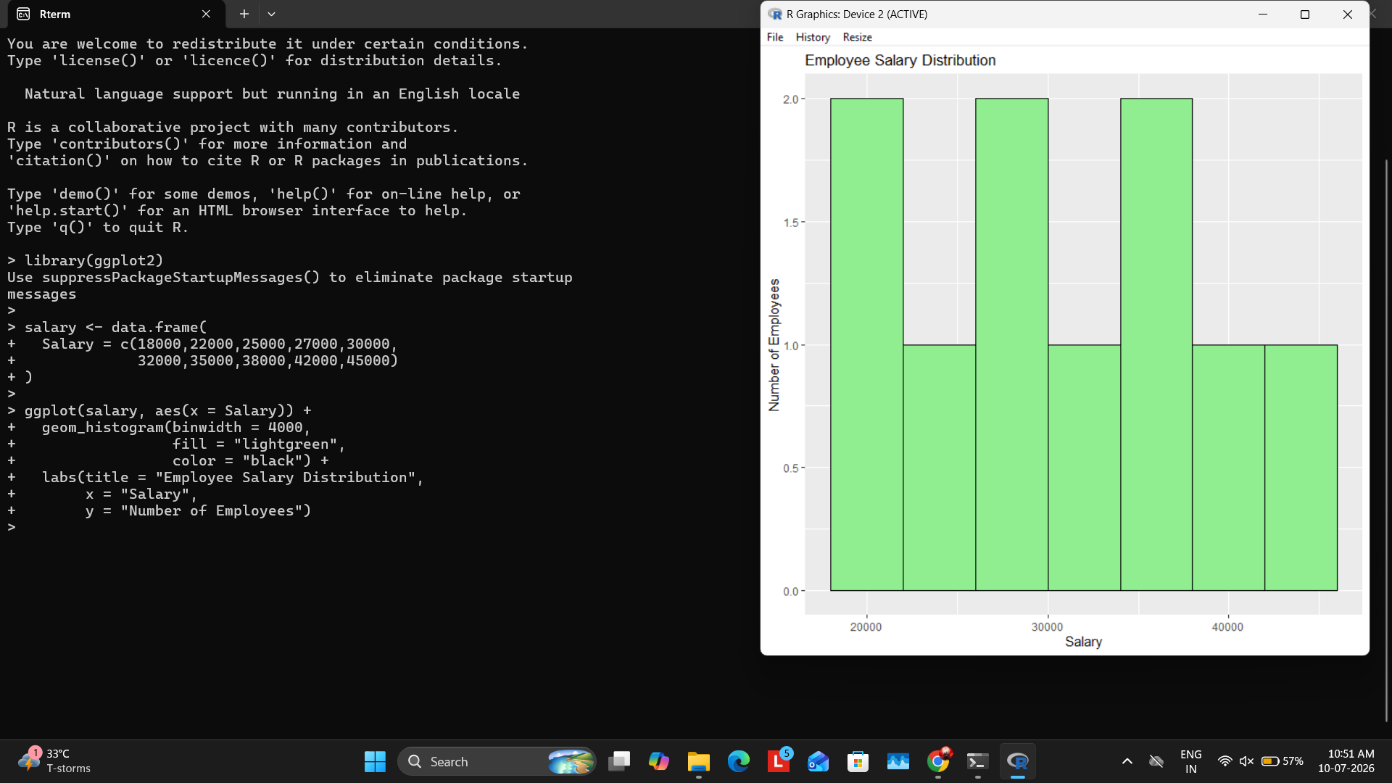

Scenario 6 – Employee Salary Distribution
R Program:
library(ggplot2)
salary <- data.frame(
Salary=c(18000,22000,25000,27000,30000,32000,35000,38000,42000,45000)
)
ggplot(salary,aes(Salary))+
geom_histogram(binwidth=4000,fill="lightgreen",color="black")+
labs(title="Employee Salary Distribution")

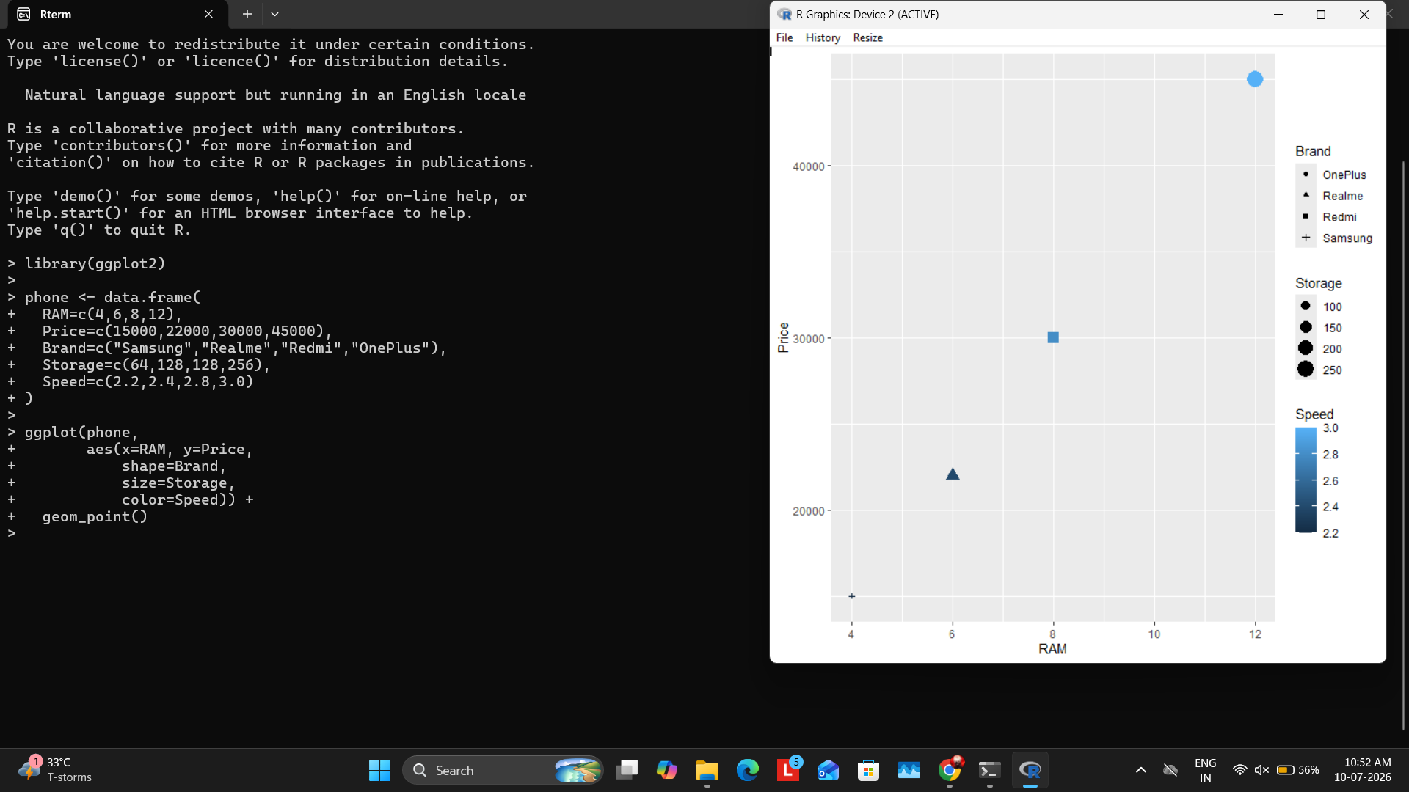

Scenario 7 – Smartphone Market Comparison
R Program:
library(ggplot2)
phone <- data.frame(
RAM=c(4,6,8,12),
Price=c(15000,22000,30000,45000),
Brand=c("Samsung","Realme","Redmi","OnePlus"),
Storage=c(64,128,128,256),
Speed=c(2.2,2.4,2.8,3.0)
)
ggplot(phone,aes(RAM,Price,shape=Brand,size=Storage,color=Speed))+
geom_point()

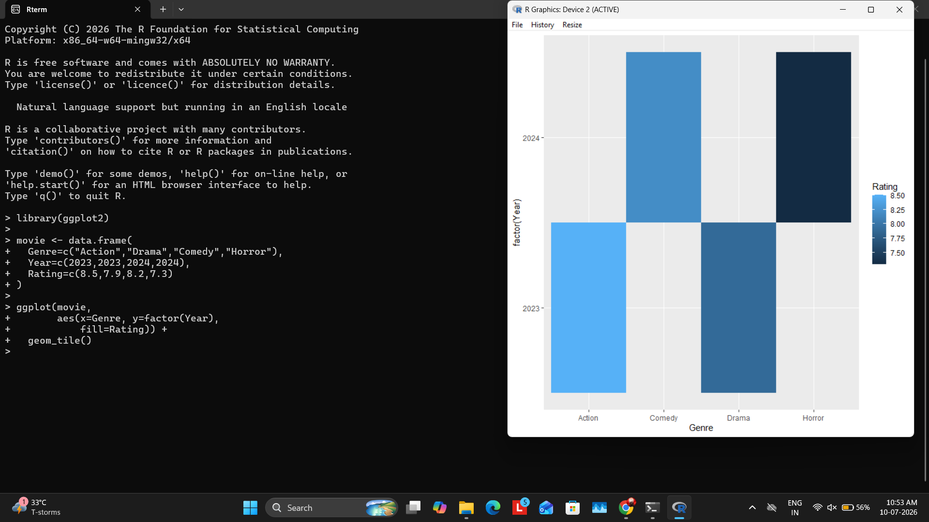

Scenario 8 – Online Movie Rating Analysis
R Program:
library(ggplot2)
movie <- data.frame(
Genre=c("Action","Drama","Comedy","Horror"),
Year=c(2023,2023,2024,2024),
Rating=c(8.5,7.9,8.2,7.3)
)
ggplot(movie,aes(Genre,factor(Year),fill=Rating))+
geom_tile()

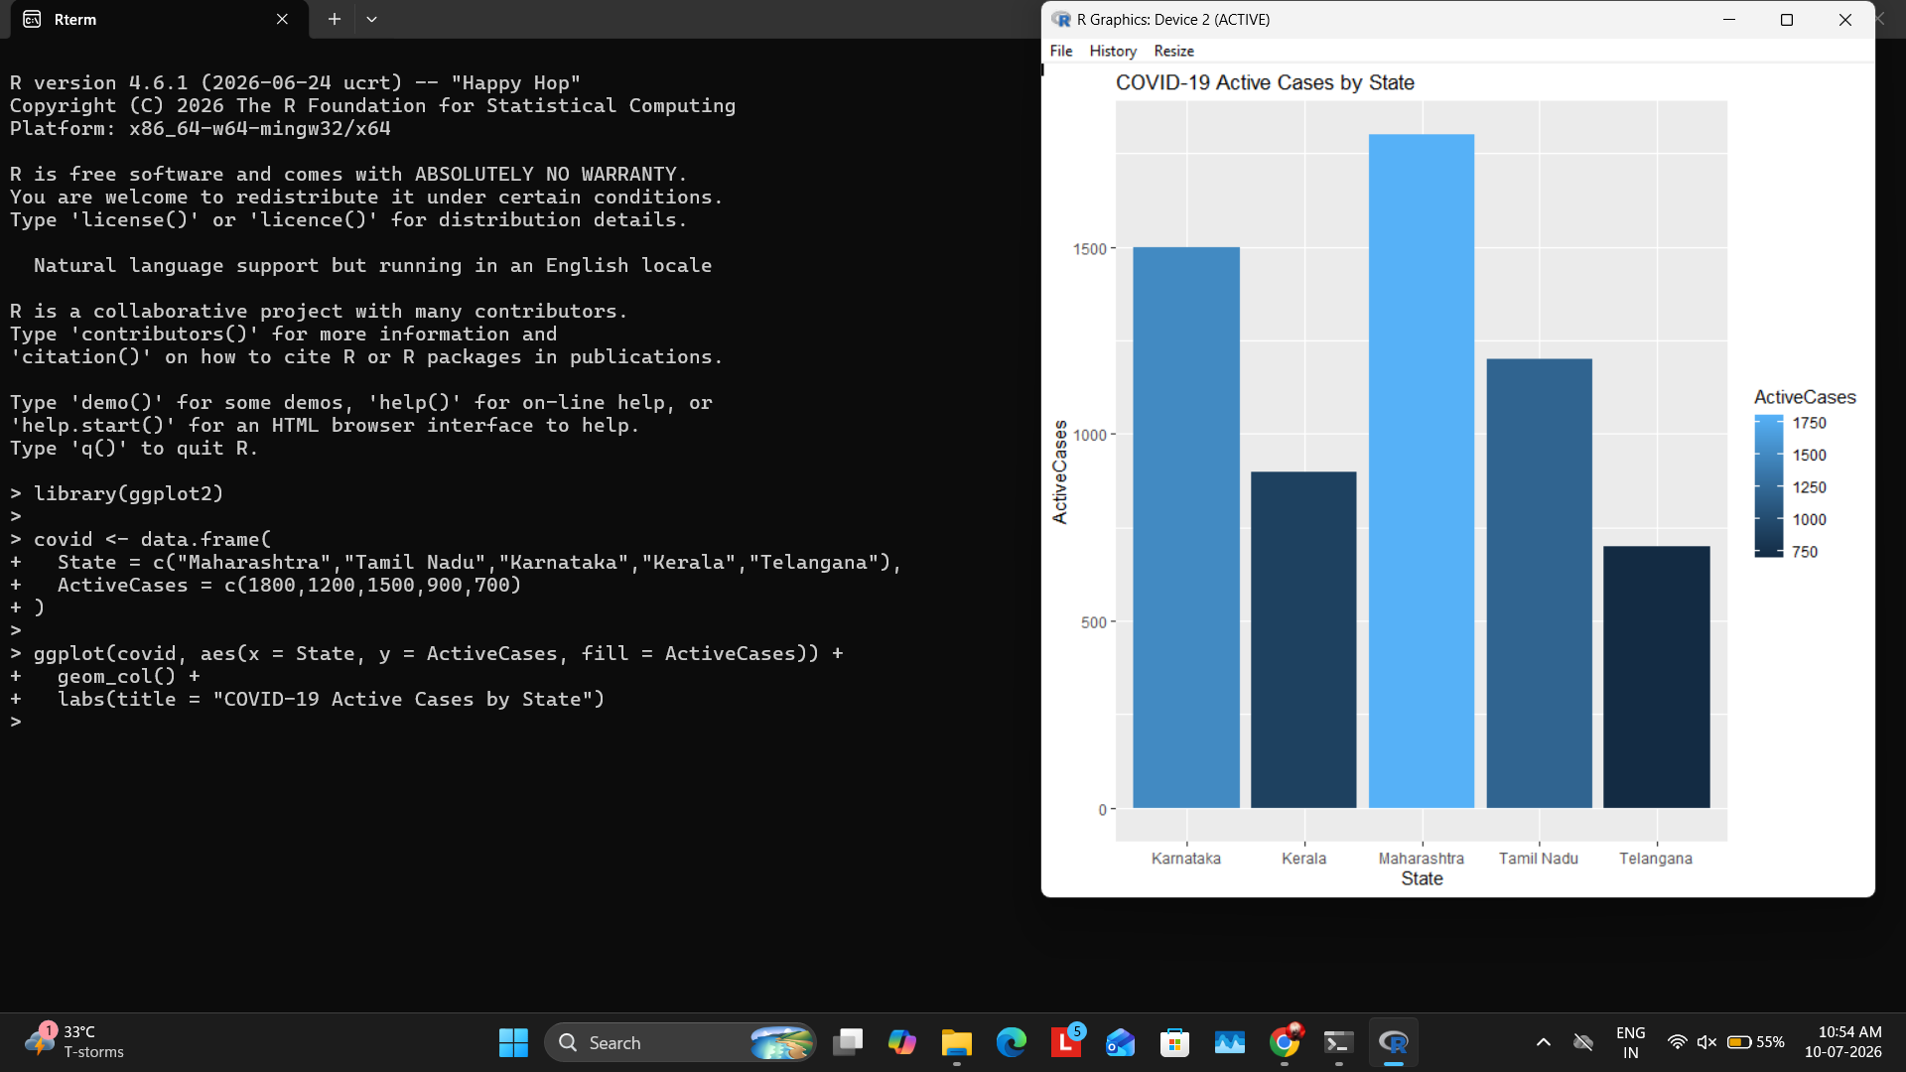

Scenario 9 – COVID-19 State-wise Analysis
R Program:
library(ggplot2)
covid <- data.frame(
State=c("Maharashtra","Tamil Nadu","Karnataka","Kerala","Telangana"),
ActiveCases=c(1800,1200,1500,900,700)
)
ggplot(covid,aes(State,ActiveCases,fill=ActiveCases))+
geom_col()+
labs(title="COVID-19 Active Cases by State")

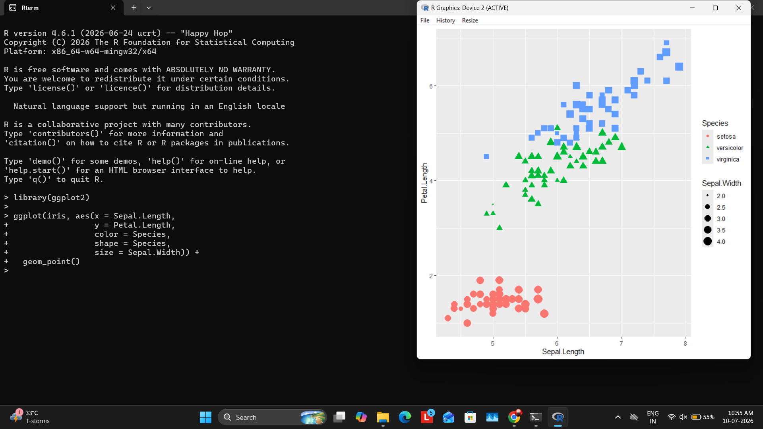

Scenario 10 – Iris Flower Classification
R Program:
library(ggplot2)
ggplot(iris,
aes(Sepal.Length,Petal.Length,
color=Species,
shape=Species,
size=Sepal.Width))+
geom_point()



